Creating a Signature in Office 365 Outlook

Select the Gear icon in the top right corner of Outlook



Select View All Outlook Settings at the Bottom of the Menu

Select Compose and Reply

Type in your Signature in the Email Signature Box

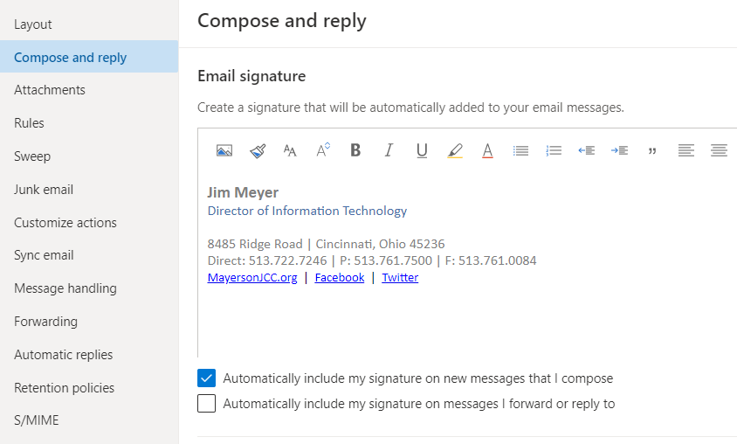

You may want to check Automatically include my signature on new messages that I compose.
You may want to check Automatically include my signature on new messages that I forward or reply to.

Select SAVE in the bottom right corner of the settings box.

Close the settings box by hitting the X in the top right corner for Windows and top left corner on a Mac.

